Chapter 13, Solution 83.

The schematic is shown below. In the AC Sweep box, we set Total Pts = 1, Start Freq = 0.1592, and End Freq = 0.1592. After simulation, the output file includes

FREQ IM(V_PRINT1) IP(V_PRINT1)
1.592 E–01 1.080 E+00 3.391 E+01

FREQ VM($N_0001) VP($N_0001)
1.592 E–01 1.514 E+01 –3.421 E+01

i.e. i_{X} = 1.08∠33.91° A, V_{x} = 15.14∠–34.21° V.
This is most likely incorrect and needs to have the values of turns changed. Clearly the turns ratio makes L2 = 400000 and L1 = 4000000.
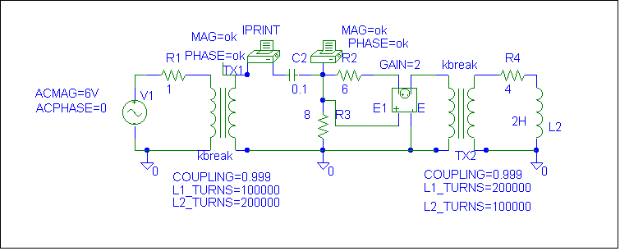

Checking with hand calculations.

Loop 1. –6 + 1I₁ + V₁ = 0 or I₁ + V₁ = 6 (1)

Loop 2. –V₂ – j10I₂ + 8(I₂–I₃) = 0 or (8–j10)I₂ – 8I₃ – V₂ = 0 (2)

Loop 3. 8(I₃–I₂) + 6I₃ +2V_{x} +V₃ = 0 or –8I₂ + 14I₃ + V₃ + 2V_{x} = 0 but
V_{x} = 8(I₂–I₃), therefore we get 8I₂ – 2I₃ + V₃ = 0 (3)

Loop 4. –V₄ + (4+j2)I₄ = 0 or (4+j2)I₄ – V₄ = 0 (4)

We also need the constraint equations, V₂ = 2V₁, I₁ = 2I₂, V₃ = 2V₄, and I₄ = 2I₃. Finally,
I_{x} = I₂ and V_{x} = 8(I₂ – I₃).

We can eliminate the voltages from the equations (we only need I₂ and I₃ to obtain the required answers) by,

(1)+0.5(2) = I₁ + (4–j5)I₂ – 4I₃ = 6 and

0.5(3) + (4) = 4I₂ – I₃ + (4+j2)I₄ = 0.
2V_{x}
Next we use I₁ = 2I₂ and I₄ = 2I₃ to end up with the following equations,

(6–j5)I₂ – 4I₃ = 6 and 4I₂ + (7+j4)I₃ = 0 or I₂ = –[(7+j4)I₃]/4 = (–1.75–j)I₃
= (2.01556∠–150.255°)I₃

This leads to (6–j5)(–1.75–j)I₃ – 4I₃ = (–10.5–5–4+j(8.75–6))I₃ = (–19.5+j2.75)I₃ = 6 or

I₃ = 6/(19.69296∠171.973°) = 0.304677∠–171.973° amps
= –0.301692–j0.042545.
I₂ = (–1.75–j)(0.304677∠–171.973°)
= (2.01556∠–150.255°)(0.304677∠–171.973°)
= 614.096∠37.772° mA = 0.48541+j0.37615
and I₂ – I₃ = 0.7871+j0.4187 = 0.89154∠28.01°.

Therefore,
V_{x} = 8(0.854876∠22.97°) = 7.132∠28.01° V

I_{x} = I₂ = 614.1∠37.77° mA.

Checking with MATLAB we get A and X from equations (1) – (4) and the four constraint equations.

>> A = [1 0 0 0 1 0 0 0;0 (8-10j) -8 0 0 -1 0 0;0 8 -2 0 0 0 1 0;0 0 0 (4+2j) 0 0 0 -1;0 0 0 0 -2 1 0 0;1 -2 0 0 0 0 0 0;0 0 0 0 0 0 1 -2;0 0 -2 1 0 0 0 0]

A =

1.0000 0 0 0 1.0000 0 0 0
0 8.0000 -10.0000i -8.0000 0 0 -1.0000 0 0
0 8.0000 -2.0000 0 0 0 1.0000 0
0 0 0 4.0000 + 2.0000i 0 0 0 -1.0000
0 0 0 0 -2.0000 1.0000 0 0
1.0000 -2.0000 0 0 0 0 0 0
0 0 0 0 0 0 1.0000 -2.0000
0 0 -2.0000 1.0000 0 0 0 0

>> X = [6;0;0;0;0;0;0;0]

X =

6
0
0
0
0
0
0
0

>> Y = inv(A)*X

Y =

0.9708 + 0.7523i = I₁ = 1.2817∠37.773° amps
0.4854 + 0.3761i = I₂ = 614.056∠37.769° mA = I_{x}
-0.3017 - 0.0425i = I₃ = 0.30468∠–171.982° amps
-0.6034 - 0.0851i = I₄
5.0292 - 0.7523i = V₁
10.0583 - 1.5046i = V₂
-4.4867 - 3.0943i = V₃
-2.2434 - 1.5471i = V₄

I_{x} = 614.1∠37.77° mA

Finally, V_{x} = 8(I₂ – I₃) = 8(0.7871+j0.4186) = 8(0.891489∠28.01°)

= 7.132∠28.01° volts

